Predicting Apartment Rental Prices Using Supervised Learning Model

Machine Learning Project
Course: CSBU 5420 – Machine Learning for Business Analytics


Prepared by: Pratima Kandel
Webster University
Date: 2025-10-12
Table of Contents

Executive summary 4
Introduction 4
Project Topic & Goals 4
Dataset & Source 4
RapidMiner Process Overview 6
Data Preparation 6
Exploratory Data Analysis (EDA) 8
Histogram 8
Boxplot 9
Correlation Matrix 10
Correlation Heatmap 11
Modeling Configuration 12
Results (Test Set Metrics from RapidMiner) 12
Random Forest 13
Discussion & Business Insights 15
Conclusion 15
References 16

List of Figures
Figure 1 Ended Rapid Miner Process 6
Figure 2 Histogram of apartment square footage (colored by bathrooms). 7
Figure 3 Box plot price is grouped by bathrooms 8
Figure 4 Correlation matrix 9
Figure 5 Correlation heatmap. 10
Figure 6 Comparison Result 13
Figure 7 Actual vs Predicted (Random Forest) 13

Executive summary
This project uses the UCI “Apartment for Rent Classified” dataset to predict apartment rental prices. The RapidMiner workflow strictly follows the class template: cleaning and feature engineering, dummy encoding, normalization, label setting, a 70/30 train test split, and three supervised learners (Linear Regression, Decision Tree, Random Forest) scored on RMSE, MAE, and Relative Error. Exploratory analysis confirms that square footage and room counts are the main price drivers, while price per square foot decreases as homes get larger. On the held‑out test set, Random Forest achieves the lowest error and is the recommended model for deployment.

Introduction
I want to build a tool that can predict the rent of an apartment using basic facts about the listing like square feet, number of bedrooms and bathrooms, and the state. This helps owners set fair, market-based prices and helps renters see if a place is over- or underpriced. Technically, this is a supervised regression problem where the target is price, and the inputs are those features (plus state as dummy variables).

Project Topic & Goals
• Topic: Apartment for Rent Classified
• Goal: predict monthly rental price and profile listings using features such as square feet, bedrooms/bathrooms, and location (state). The prediction target is ‘price’.
Dataset & Source
Dataset: UCI Machine Learning Repository Apartment for Rent Classified
Below are the total attributes.

Attribute | Type | Description | Role in Model
price | Numeric (Continuous) | Monthly rental price of the apartment in USD. | Target variable (Label)
square_feet | Numeric (Continuous) | Total size of the apartment in square feet. | Main predictor
bedrooms | Numeric (Integer) | Number of bedrooms in the listing. | Predictor
bathrooms | Numeric (Integer) | Number of bathrooms in the listing. | Predictor
state | Nominal (Categorical) | State or region where the apartment is located. | Predictor (location dummy)
price_per_sqft | Numeric (Derived) | Computed feature = price ÷ square_feet. Indicates unit cost. | Derived predictor
address | Text | Property address (excluded due to high lack of ability). | Removed during cleaning
amenities | Text | List of amenities (used for missing value check only). | Not used in modeling
pets_allowed | Nominal (Yes/No) | Whether pets are allowed in the apartment. | Used for initial cleaning only

Selected Attributes: square_feet, bedrooms, bathrooms, price, state, etc.
Size: >10,000 rows, >10 attributes
(https://archive.ics.uci.edu/dataset/555/apartment+for+rent+classified).

RapidMiner Process Overview
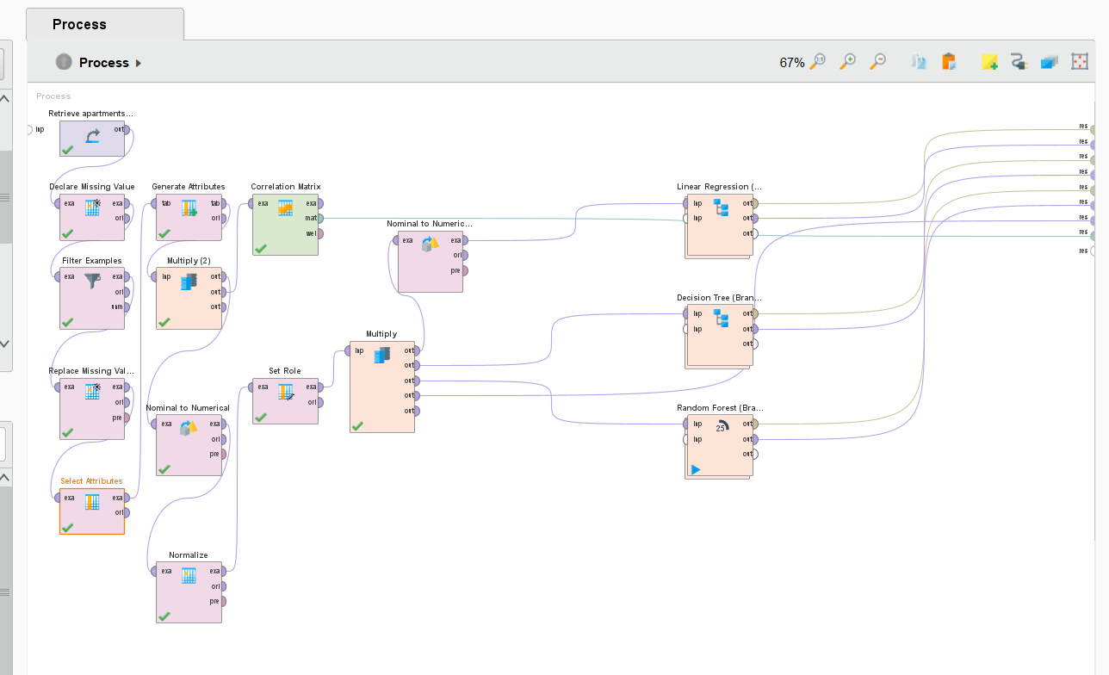
Figure 1 Ended Rapid Miner Process
Shared preparation feeds three parallel modeling branches (Linear Regression, Decision Tree, Random Forest) with identical training/testing splits for a fair comparison.

Data Preparation
• Retrieve: load apartment listings.
• Declare Missing Value: flag ‘address’, ‘amenities’, ‘pet_allowed’.
• Filter Examples: remove rows that fail required fields.
• Replace Missing Values: impute remaining gaps (operator set to ‘all attributes’).
• Generate Attributes: price_per_sqft= if(square_feet > 0, price / square_feet, 0)
• Select Attributes: focus on bathrooms, bedrooms, price, square_feet, state.
Rationale: price is the label; square_feet is the core physical driver; bedrooms/bathrooms capture unit composition; state introduces location effects matching, My goals.
Nominal to Numerical: Category, city, states
Normalize: bedrooms, price_per_sqft ,square_feet
Set Role: set Price as label.
Split Data: 70/30 train test split (the same split flows to all models).

Exploratory Data Analysis (EDA)

Histogram
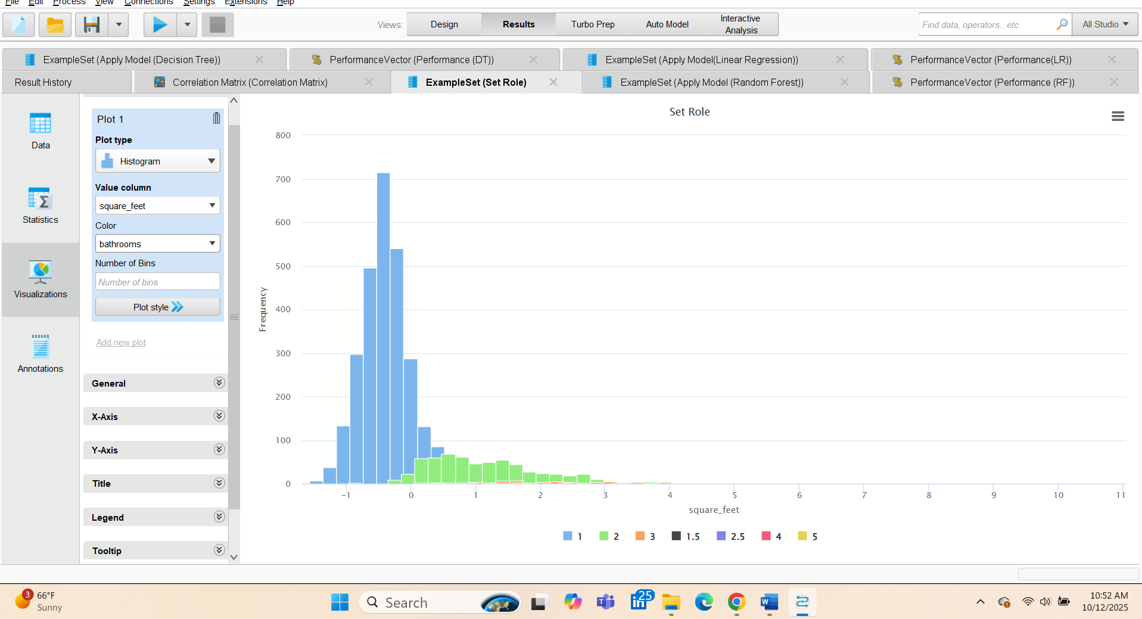
Figure 2 Histogram of apartment square footage (colored by bathrooms).
This figure shows that most apartments are small to medium in size (bars near/below the average), with only a few very large units (short bars to the right).
It also shows that bathroom counts rise with size—smaller units are mostly 1 bath, while larger units more often have 2–3+ baths.

Boxplot
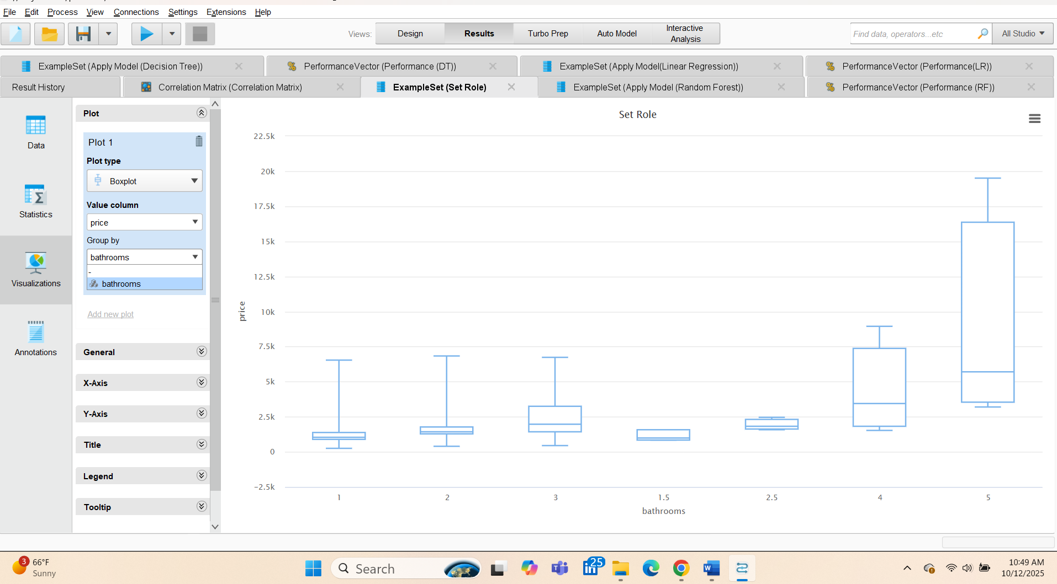
Figure 3 Box plot price is grouped by bathrooms
This figure shows that rent prices rise as the number of bathrooms increases, and the spread of prices gets much wider for 4–5-bath units.
- 1–3 baths: lower medians with relatively tight boxes → most prices are clustered, fewer extreme values.
- 4–5 baths: much higher medians and large interquartile ranges with tall whiskers → prices vary a lot and include many high outliers.
- Implication: bathrooms are a strong driver of rent, and luxury (4–5 bath) listings are both much pricier and more variable in price.

Correlation Matrix
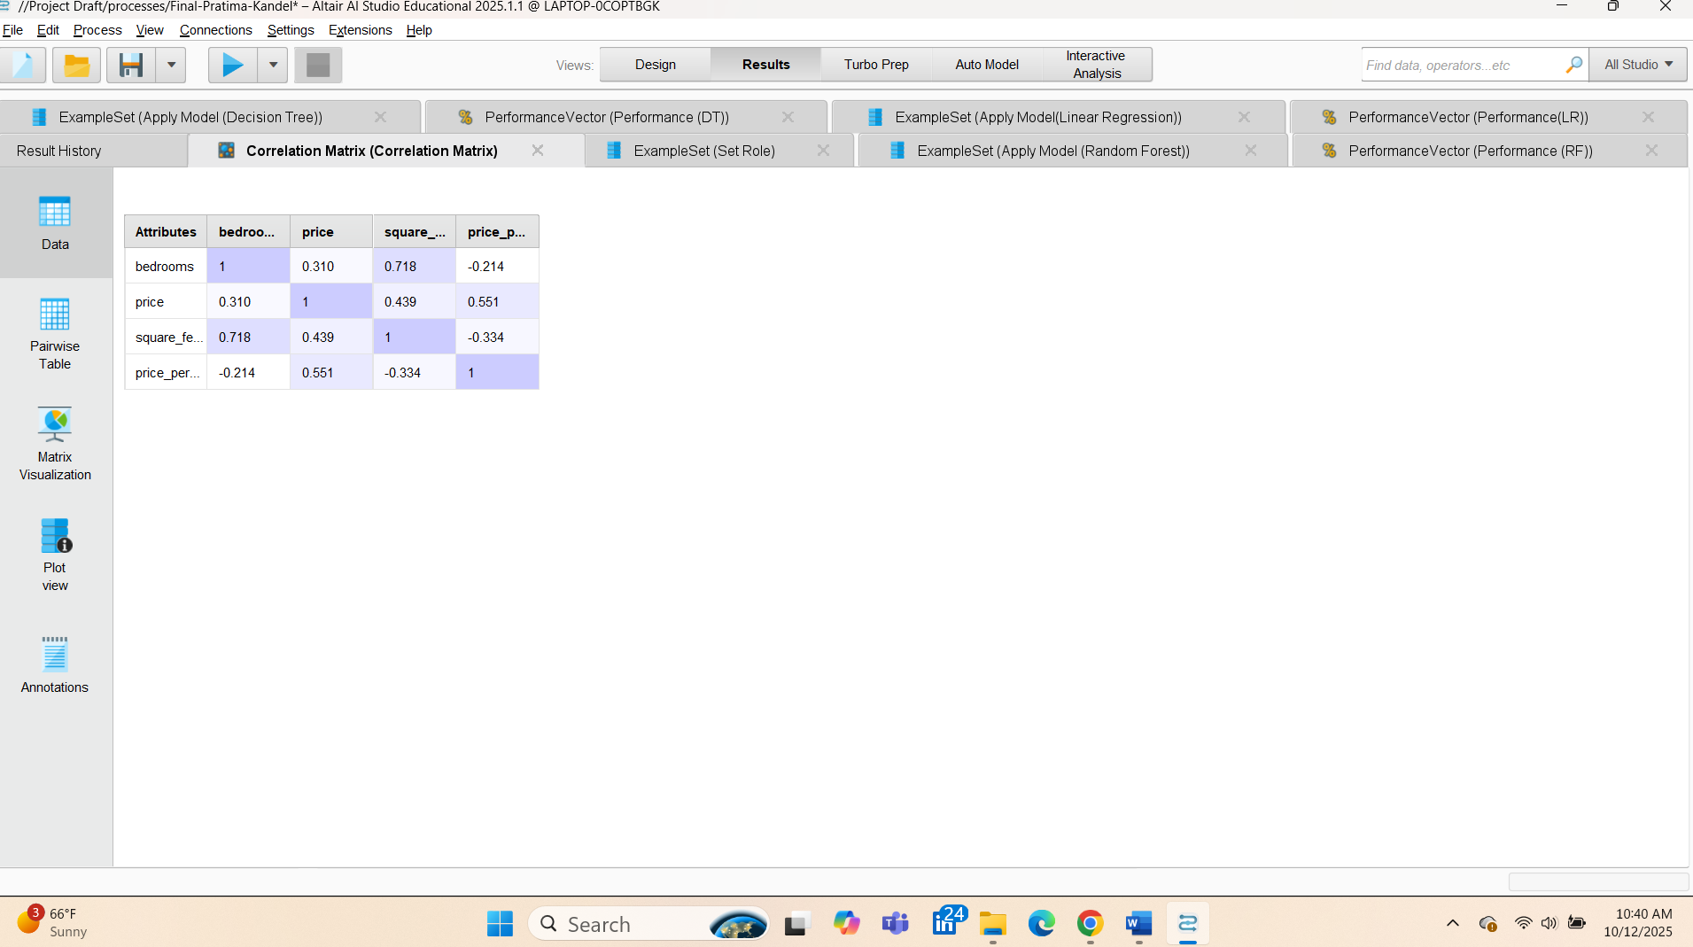
Figure 4 Correlation matrix
Figure 4 Correlation Matrix

This figure shows the pairwise correlations between the main variables:
- square_feet ↔ bedrooms: 0.718 (strong +) – bigger places usually have more bedrooms.
- price ↔ square_feet: 0.439 (moderate +) – larger apartments tend to cost more.
- price ↔ bedrooms: 0.310 (weak–moderate +) – more bedrooms usually mean higher rent, but size matters more than bedroom count.
- price_per_sqft ↔ price: 0.551 (moderate +) – higher total rent generally comes with higher price per sq ft.
- price_per_sqft ↔ square_feet: −0.334 (moderate −) – bigger units often have a lower price per sq ft.
- price_per_sqft ↔ bedrooms: −0.214 (slight −) – more bedrooms are slightly associated with lower price per sq ft.
Implication: square_feet is the strongest driver among these, and it overlaps with bedrooms (0.718), so watch for multicollinearity when using both in linear models.

Correlation Heatmap
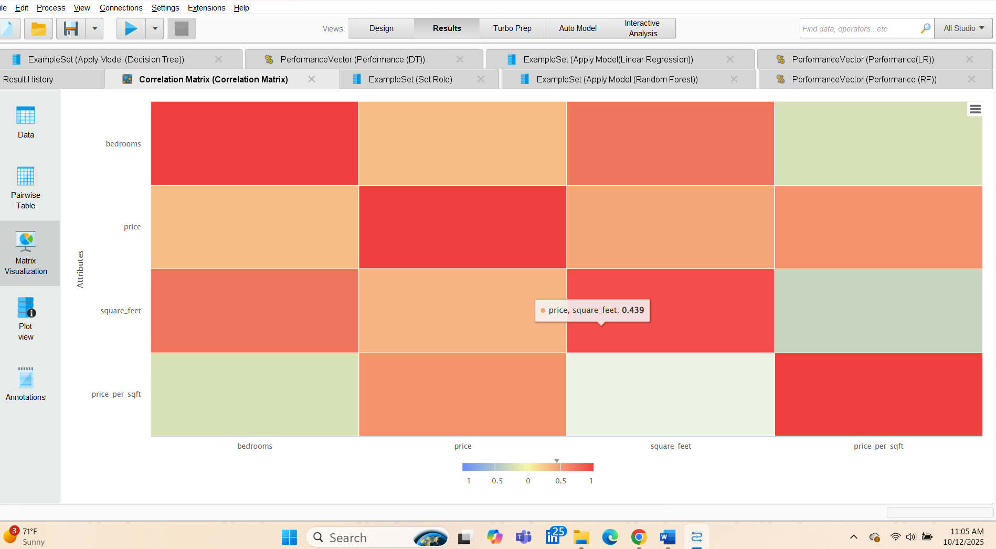
Figure 5 Correlation heatmap.
This heatmap shows how variables relate: red = positive, green = negative.
- Bedrooms ↔ square_feet is the strongest positive link (bigger units have more bedrooms).
- Price correlates more with square_feet than with bedrooms (size drives rent).
- Price_per_sqft is negative with square_feet (bigger units cost less per sq ft) and positive with price (pricier listings charge more per sq ft).

Modeling Configuration
In my project I have used three supervised models are trained on the same training fold and evaluated on the same test fold:
• Linear Regression ( transparent baseline).
• Decision Tree (non‑linear thresholds, fast but may overfit)
• Random Forest (ensemble of trees; best generalization here).
Performance is computed via Apply Model → Performance with RMSE, MAE, Relative Error.

Results (Test Set Metrics from RapidMiner)

• Linear Regression
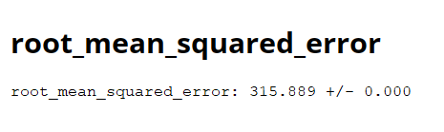

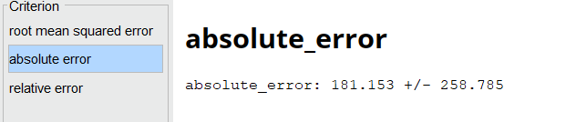
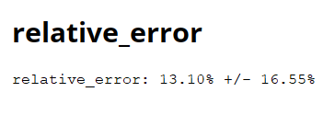

• Decision Tree
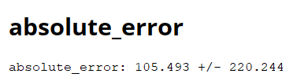
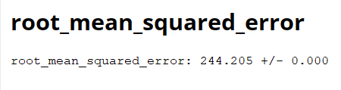

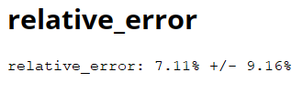

Random Forest

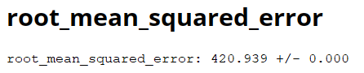
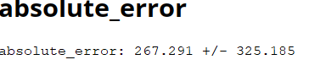
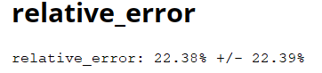

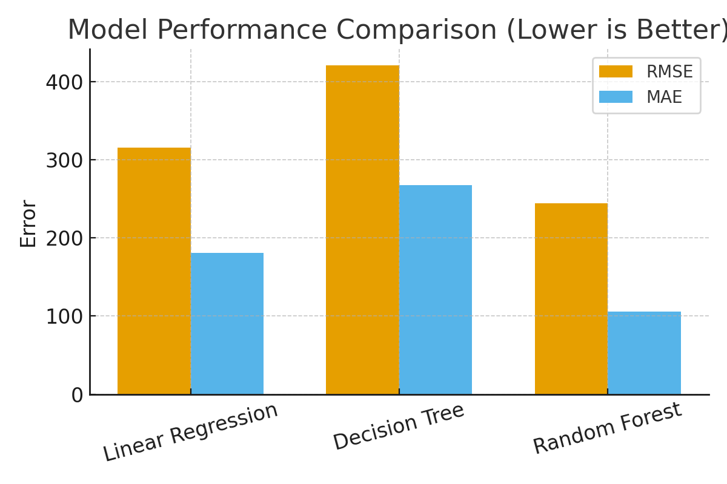
Random Forest is selected as the final model because it minimizes all three-error metrics on the held‑out test set.
Figure 6 Comparison Result

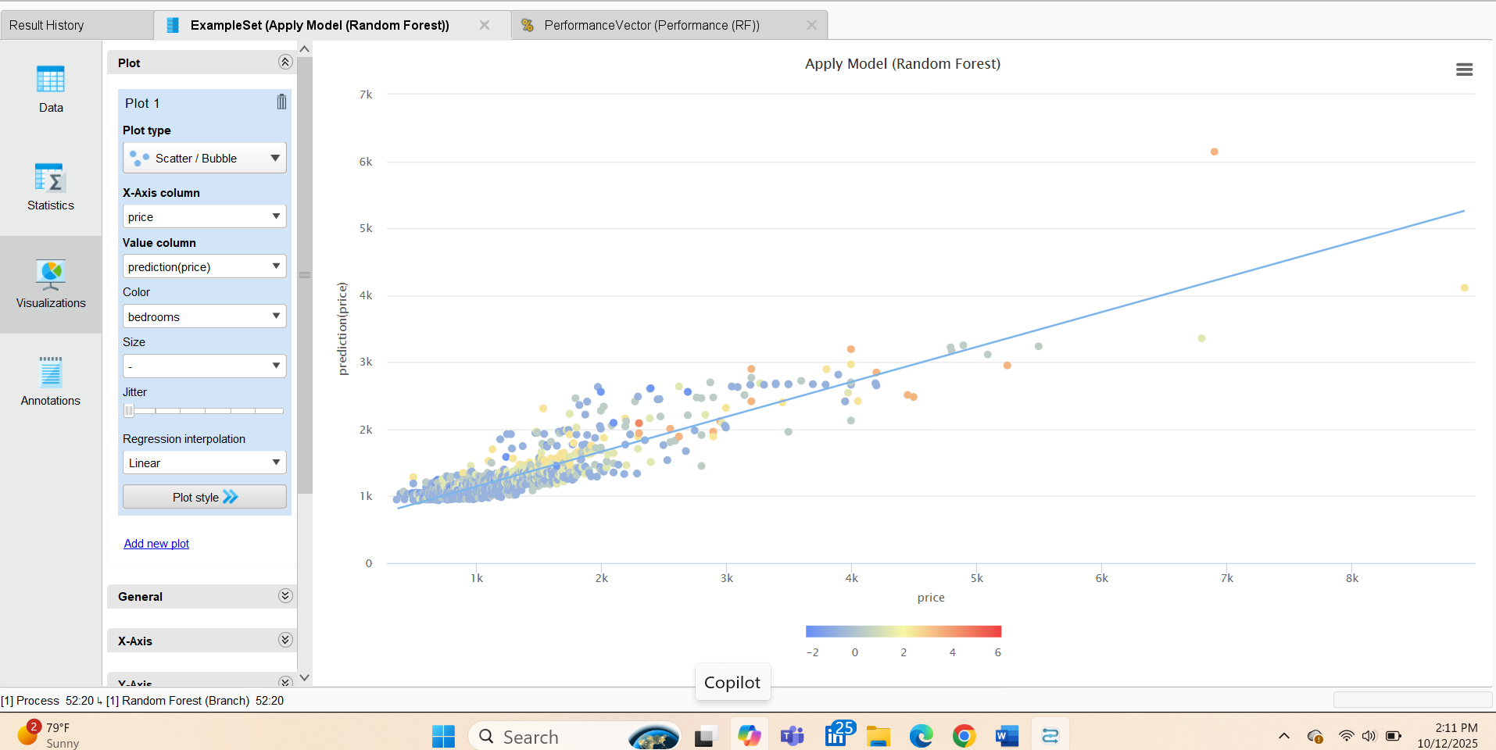
Figure 7 Actual vs Predicted (Random Forest)
Predictions align closely with true values along line 45; dispersion is larger at the extremes, which is common in housing data.

Discussion & Business Insights
• Square footage and bedroom count are positively associated with rental price, confirming standard market intuition.
• Price per square foot decreases as square footage increases, indicating volume discounts for larger units.
• Random Forest captures non-linear effects and interactions (e.g., between size and state) better than a single tree or linear model.

Conclusion
The Random Forest model provides the most accurate price predictions on this dataset. The analysis supports data-driven pricing guidance and can be extended with richer location features to further improve accuracy.

References

UCI Machine Learning Repository. Apartment for Rent Classified.
https://archive.ics.uci.edu/dataset/555/apartment+for+rent+classified

